Test # 188
Instrument Name Consistometer
Instrument Type Consistometer
Test Start 20/02/01 11:40
Test Stop 2:12:09
Well ID # Unidentified
Customer KOGALYM-LUKOIL AIK
Cement Class G
Additives 1.35%TDF-1+Defoamer
Cement Mfr DYKERHOFF
BHCT 70
BHST 70
Density 1900
Fluid Loss 30cc/30min
Job Type 146 MM CSG HESITATION SQUEEZE
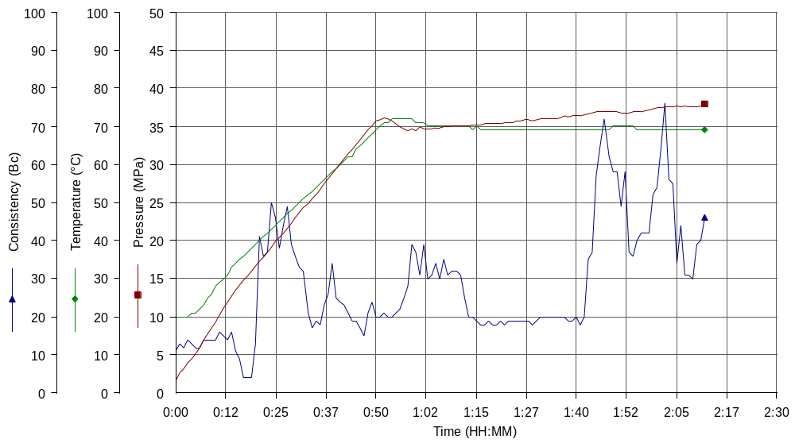
Comments MPa: 34.04(50.3min), 38.4(100.6min); T: 70(50.3min); Standard API Hesitation Squeeze Cycle

